A Simple Guide to Organising Bell Projects
Introduction
There are two sorts of scheme:-
- a minor scheme that does not require a faculty
- all other schemes that do require a faculty.
A faculty is the equivalent of church planning permission. The application (which is now free) must be agreed by the PCC. When agreed it is sent to Church House in Oxford by the PCC/Church Authorities
How to Plan Your Scheme
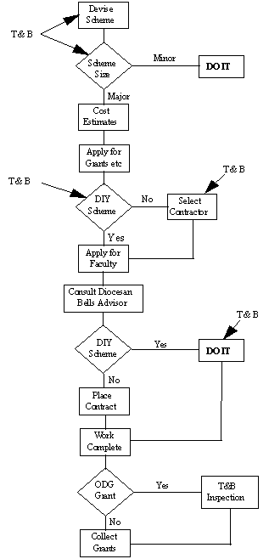
Usually, minor schemes are those which cost less than £300 but you should check with Church House to be sure that your scheme qualifies.
There are many points in the project where the Towers and Belfries (T & B) committee can offer advice. Most of these are indicated on the flow-chart which shows how the average project might proceed.

