Radley Rope Course

Eleven enthusiastic ‘students’, mostly tower steeple keepers, attended a recent one-day course at the very upmarket Radley Church Hall on rope splicing presented by Tony Crabtree and several of his experts from the ODG Towers and Belfries committee.

The course covered the all-important revision of health and safety aspects, through a clear and concise description of how ropes are made, the differences between natural and synthetic fibres and where they should be used on a bell. The team then demonstrated how a short splice – joining two ends of a cut rope, usually to eliminate a frayed portion – is carried out, then the technique for a long splice where the rope goes over pulleys. Lastly, how two ropes of different materials are joined. A natural fibre rope is kindest to the hands and is usually employed at the tail end of the rope where it is handled and gripped. A polyester rope is less kind but does not stretch (if pre-stretched at manufacture) so can be utilised from wheel to sally.
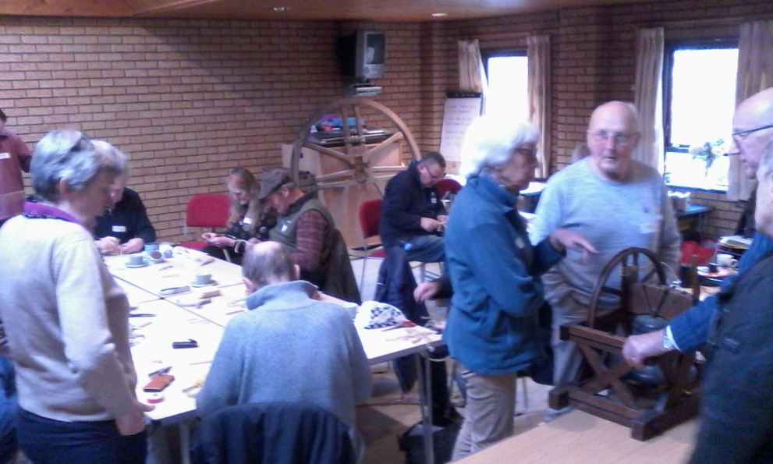
Some of us got the hang of the splicing methods quickly, others less so, but by the end of the course we had all managed to carry out the splicing tasks competently! An excellent course and many thanks to Tony and his colleagues for so generously giving up their time and expertise.
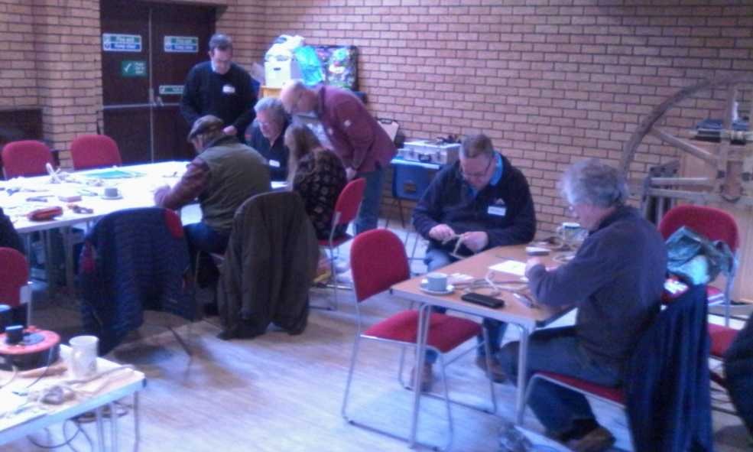
Tony Hoskinson Feb 2022
Hardwick tower

