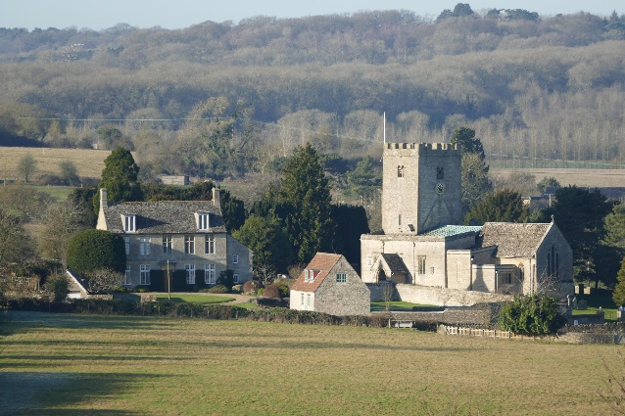
Witney and Woodstock Branch of Church Bell Ringers
Branch Social 8th July
St Mary's Church and Turner Hall
North Leigh.

Witney and Woodstock Branch of Church Bell ringers are pleased to announce that the Branch Social will be held at St Mary's Church and The Turner Hall, North Leigh on the 8th July.
There will be various and lovely BBQ food available, however, we would be very grateful if people could bring salad s and condiments for the BBQ. Soft drinks will be available. Anything stronger please bring your own.
For Desserts we are holding a competition for the best presented and tastiest Dessert. So, we would very much like a representation or two from each tower to provide the dessert(s) please.
These Desserts will be professionally observed, sampled and Judged, and of course the winner will have the “Dessert Badge of Honour”, until the next time!!!
Followed by the presentation of the First Fortnight Certificates.
The proposed evening events are as follows :-
- 6:30 – Arrive Turner Hall
- 6:30 – 7:30 General Ringing at St Mary’s
- 7:30 – Excellent BBQ food to be served.
- 8:00 – Desserts to be Judged (by a well known Dessert Judge)
- 8:15 – Presentation of First Fortnight Certificates.
- 8:30 – Onwards other activities including a “Special” raffle.
To help us manage the quantity of food available for this event we would be very grateful if you could let me know the number of people who will be attending and if there are any special dietary needs from your tower, by contacting me by the 1st July on :-
Robert.w.walton@btinternet.com

We look forward to seeing you all on the 8th July

