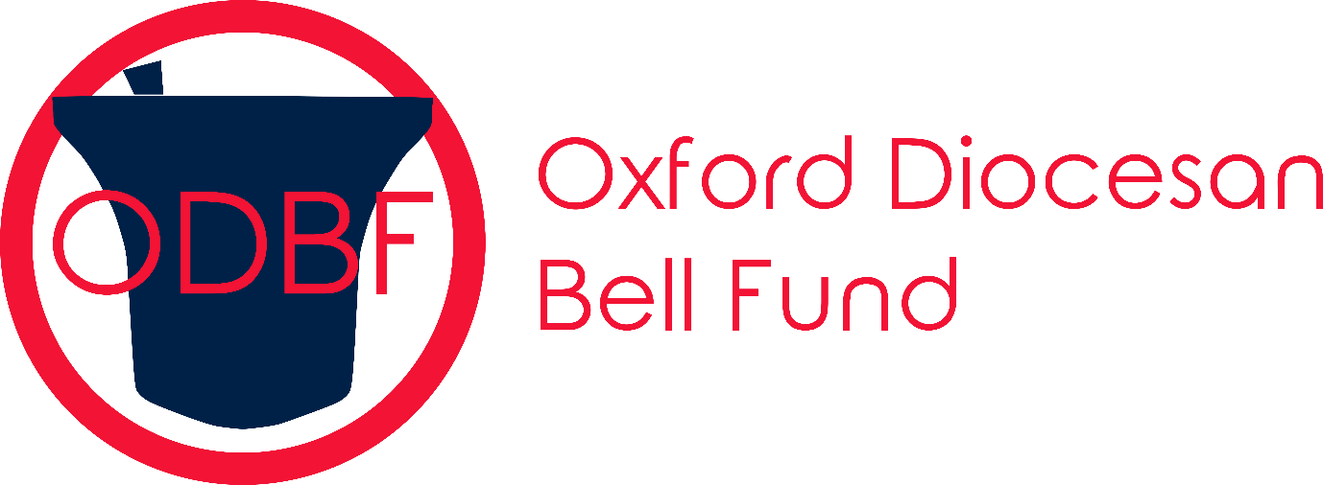
Registered Charity Number 268390

OXFORD DIOCESAN BELL FUND
2024 Leap Year Sponsored Ringing

Dear Branch Secretary

The Leap Year Sponsored Ringing Event is almost upon us again!
The Sponsored Ringing “Week” will be 24th February to 3rd March. The Shield will be presented to the Branch raising the greatest amount per head of membership. Sponsorship money can be Gift Aided and benefit from recovery of Income Tax.
It’s a great opportunity for ringers of all abilities to have some fun and do a bit of extra ringing to generate some sponsorship for the Bell Fund. It does not have to be quarter peals and peals, all sorts of ringing at all levels of ability will qualify. And where appropriate Gift Aid can be applied to the sponsorship money making it even more valuable!
The Trustees appreciate your input to the success of the Sponsored Ringing Event which is a key fund-raising activity for the Bell Fund.
Sponsorship forms will be available on the Bell Fund Web Site and can be supplied by the Secretary secretary@bellfund.odg.org.uk
Forms and payment should be returned to Stuart Gibson treasurer@bellfund.odg.org.uk The Croft, Milton Hill, Steventon, Abingdon OX13 6BD or bank transfer to:
Oxford Diocesan Bell Fund
Sort Code 30-93-93 A/C 1932969
And clearly indicating from which Branch the payment is made,

Thank You.

Alan Marchbank Chairman ODBF

