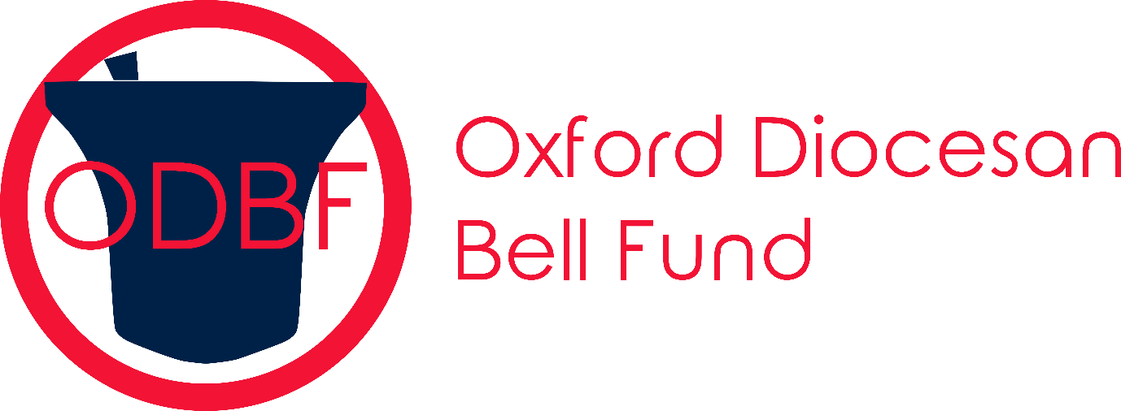
(Registered Charity No 268390)

Ringing Day Monday 6th May 2024

0900-0945 North Hinksey St Lawrence (6) 5-2-27 in B OS ref SP 494054
0930-1030 Iffley St Mary the Virgin (6) 10 cwt in Ab OS ref SP527034 T
1000-1100 Cowley St James (6) GF 5-3-3 in C OS ref SP539038 T R
1030-1130 Garsington St Mary (6) GF 8-1-6 in G OS ref SP 580020 T
1100-1200 Marsh Baldon St Peter (5) GF 7 1/2 cwt in A OS ref SU561990 (Seven Stars pub as a lunch option)
1130-1230 Drayton St Leonard St Leonard & St Catherine (6) GF 6-0-19 in B OS ref SU596964
1200-1300 Great Haseley St Peter (6) 11-1-3 in F# OS ref SP644016
1230-1330 Cuddesdon All Saints (6) 12-3-7 in F OS ref SP600030 T
1300-1400 Horspath St Giles (6) GF 5-2-9 in Bb OS ref SP571048 R (Queens Head pub as lunch a option)
1330-1430 Headington St Andrews (8) 7-3-0 in Ab OS ref SP544076 T R (White Hart or Black Boy pubs as lunch options)
1400-1500 Marston St Nicholas (6) 4-3-17 in C OS ref SP527088 T
1430-1530 Stanton St John St John the Baptist (5) 9 1/4 cwt in G# OS ref SP577093
1500-1600 Woodeaton Holy Rood (5) 7cwt in Bb OS ref SP534118]
1545-1645 Islip St Nicholas (8) 8-1-7 in G OS ref SP526140 T
1630-1730 Yarnton St Bartholomew (6) 22-1-19 in D OS ref SP477116
1700-1800 Cassington St Peter (6) 12-1-4 in F# OS ref SP454106
1730-1830 Eynsham St Leonard (6) 9-1-24 in G OS ref SP432092 T

All towers open for one hour (T = toilets, R= refreshments)
£2 per tower, or day tickets (£20)
Online payment details and e-ticket details available in advance from kt.catchmole@googlemail.com
or at the first three towers on the route.
Please bring cash as there will be limited card facilities available.

ALL PROCEEDS WILL GO TO THE OXFORD DIOCESAN BELL FUND

Any changes will be listed on the Guild Website http://odg.org.uk and at the first 3 towers of the day

